Practical 6:-

Step 1: Search Sales force

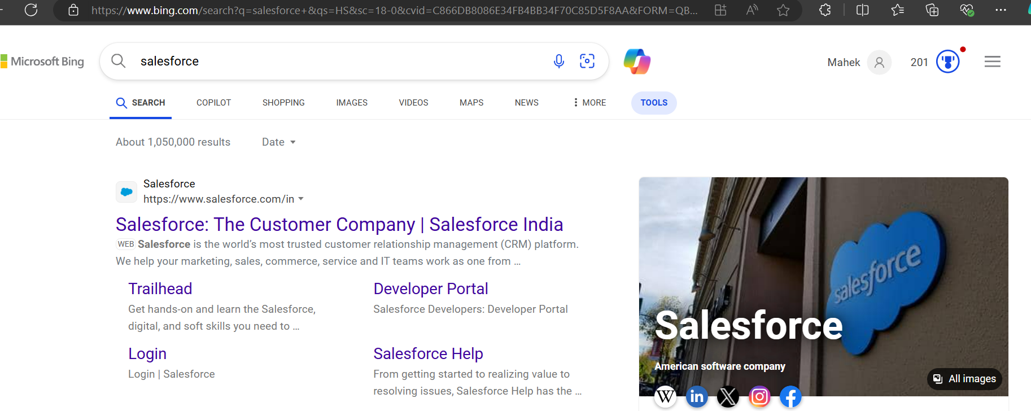  
Then search developer edition signup Salesforce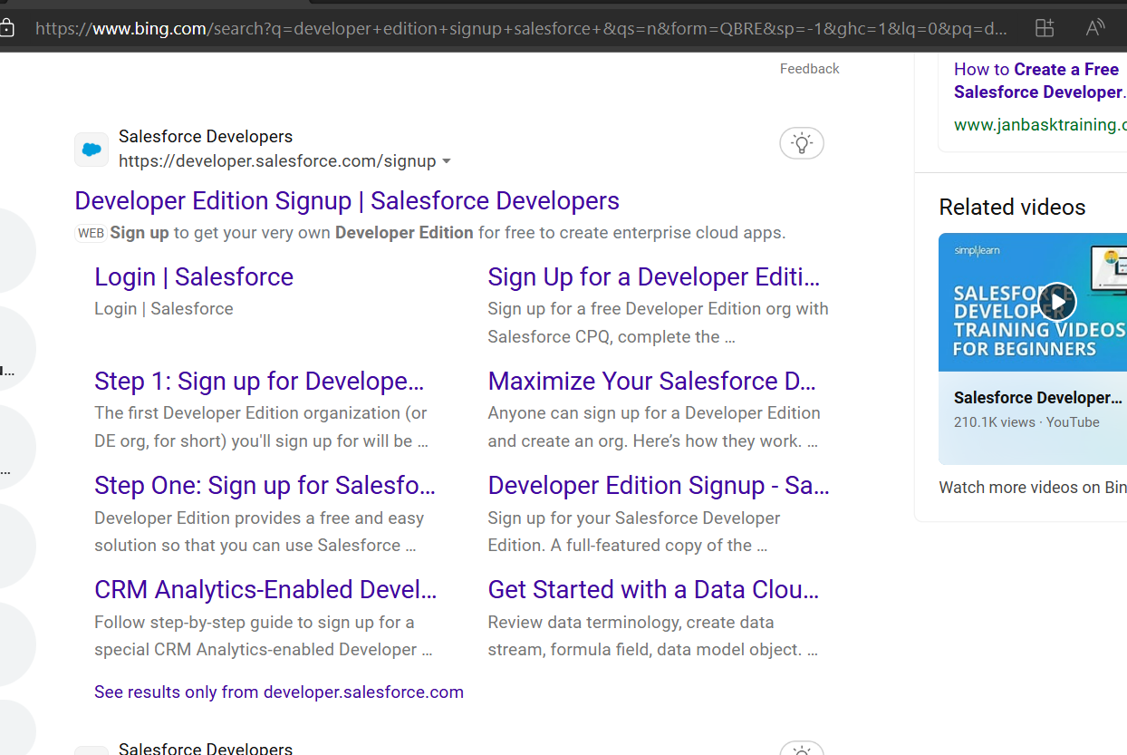

Step 2: Enter your details and signup

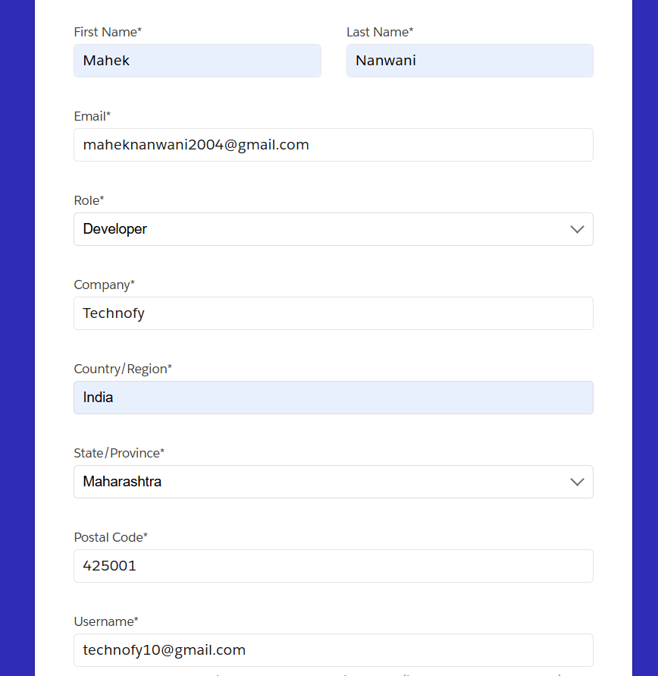

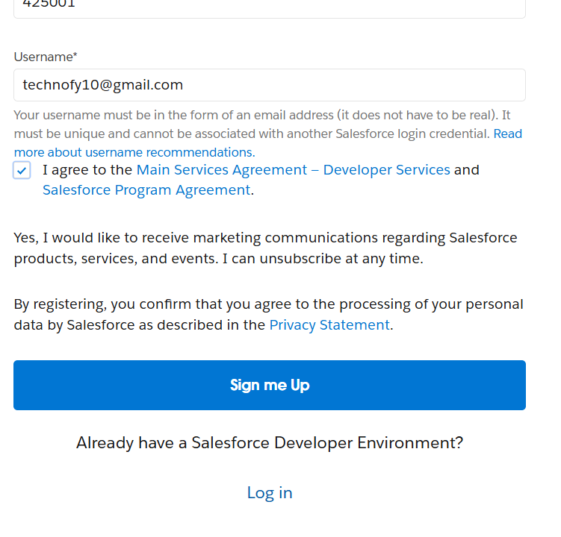

And verify your account from your mobile and set up your password

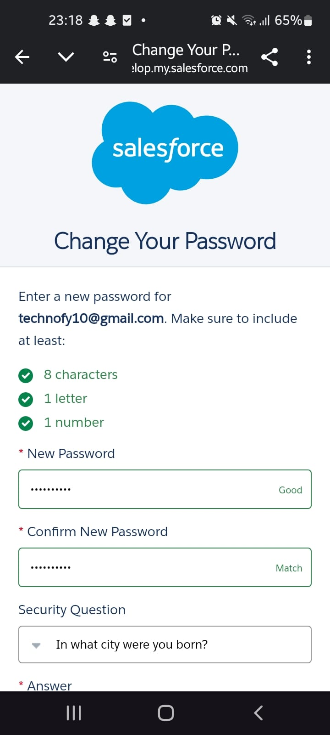

Step 3: Open your account on login Salesforce on pc

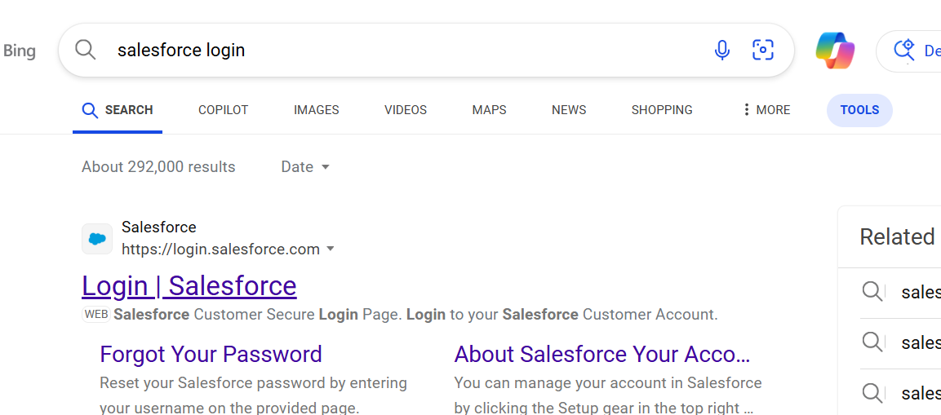



Step 4: After opening your account open your whatsapp on pc and open file named “Leads.csv”

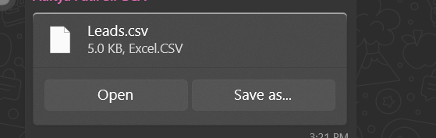

Step 5: Then search “data import wizard” on Salesforce login and launch wizard

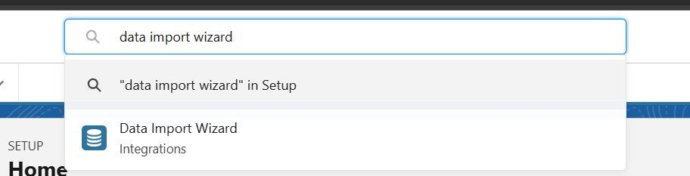

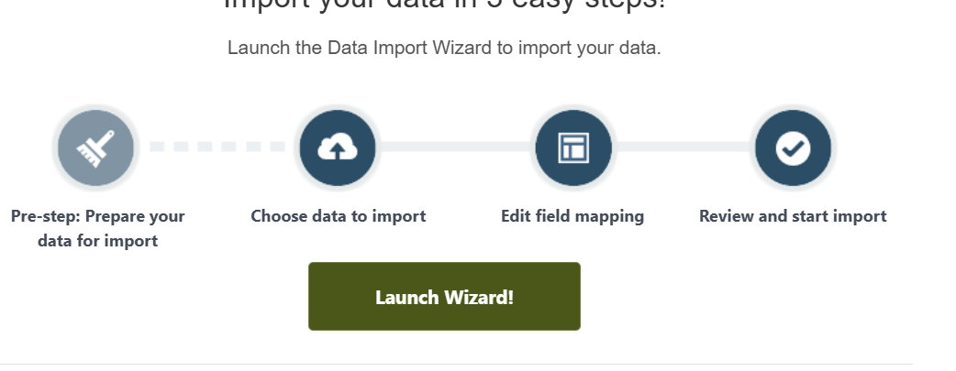

Step 6: Click on leads and then on add new records

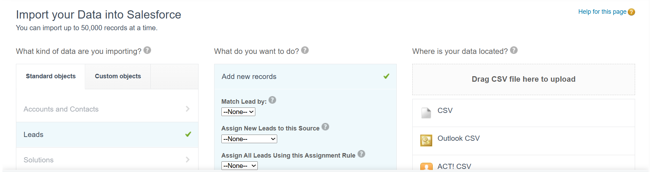

Step 7: Select CSV then click on choose file and open leads file

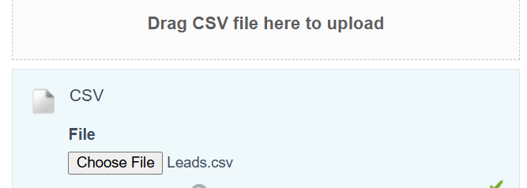

Then click on next and next

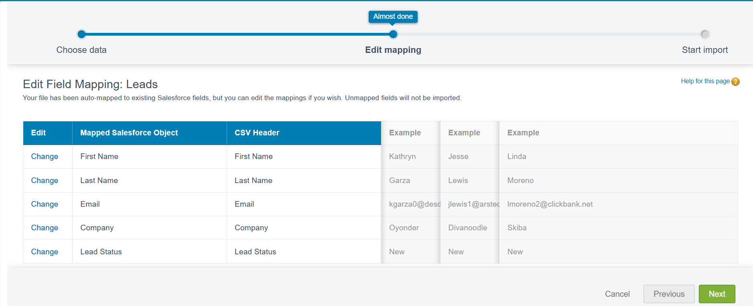

Step 8: Click on start import

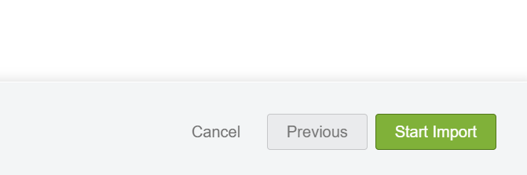

Step 9: GO to administration and to data

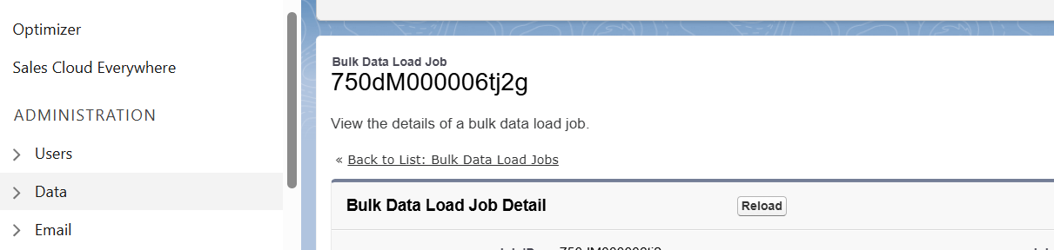

Step 10: Click on data export

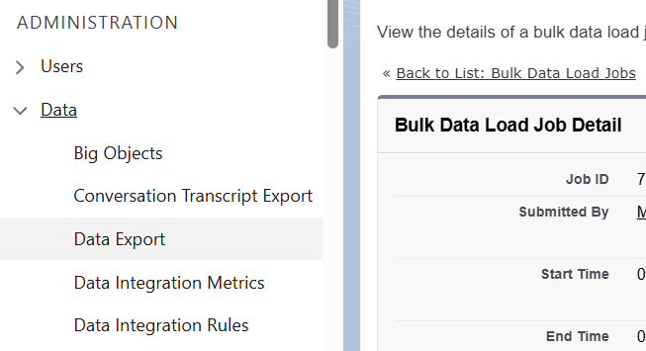

Step 11: Click on export now then on Start export

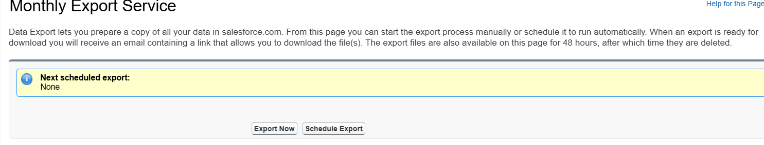

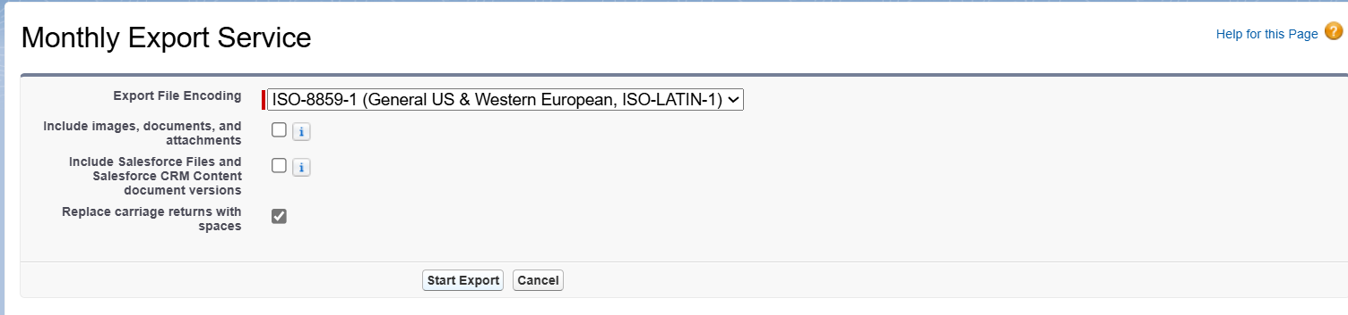

Step 12: Refresh the page and you will see a file and download it

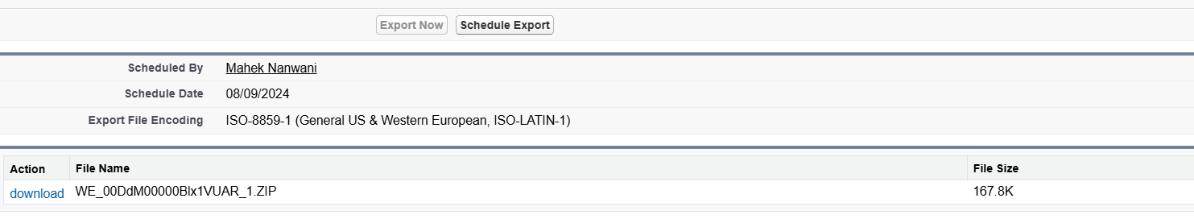

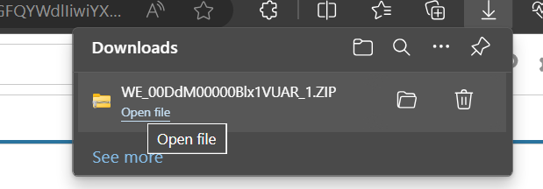

Step 13: Go to object manager Nd search leads

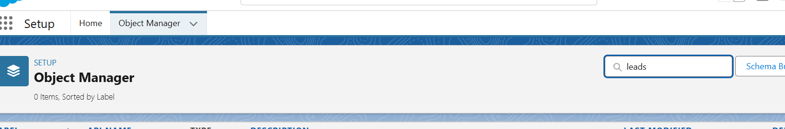

Step 14: Click on blue colored lead

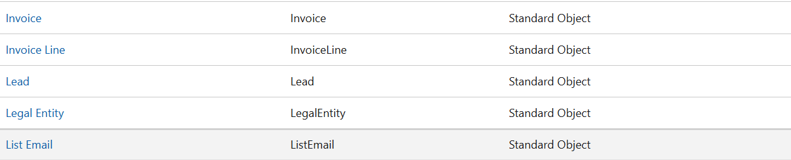

Step 15: Click on page layout

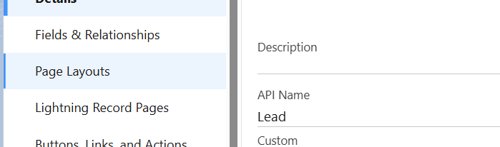

Step 16: Click on any format

